DEMONETIZATION IN INDIA (2016): ECONOMIC SHOCK OR POLICY FAILURE
-By Sayyam

INTRODUCTION
Demonetization has been attempted as a means to develop a cash-based emerging economy and to fight crime and corruption (tax evasion, counterfeiting). In 2016, the government of India chose to demonetize the 500- and 1000- rupee notes, the two largest denominations in its monetary system; they represented 86% of the circulating currency in the country.
The aim of the government (and the justification for the sudden move) was to tackle India's flourishing underground economy on a variety of fronts: eliminate counterfeit money, check tax evasion (1% of the population pays tax), eradicate black money accrued from money laundering and terrorist funding operations, and introduce a cashless economy.
Chaos hit the cash economy (around 78% of all Indian consumer transactions are made in cash), with serpentine queues waiting outside ATMs and banks, which were forced to close for a day. The specifications for the new rupee notes differ, from size to thickness, and necessitate re-calibrating ATMs: just 60% of the nation's 200,000 ATMs functioned. Even the dispensers of bills of smaller denominations ran dry. The government's limit on withdrawal limits per day only contributed to the suffering.

RBI REPORT
Reserve Bank of India in its 'Macroeconomic Impact of Demonetization - A Preliminary Assessment' report in March, 2017 has conducted impact analysis of demonetization campaign on various segments of economy and GDP growth. The report states that the agriculture also suffered due to lack of funds for seed and fertilizer purchase, the prime inputs as also payment to labor which is largely in cash. However, GDP growth slowed down to 5.7 per cent.

IMPACT
It has been observed that out of total 15.44 lakh crore currency invalidated, 15.28 lakh crore (99 per cent) have come back to the banking system, after excluding only 16,050 crores. Hence the government's hypothesis that most of it would not come back and its expectation of receiving some dividend from the central bank was broken and on the contrary, the RBI remitted much smaller dividend of just Rs 32,000 crore in 2016-17, which was much lower than the Rs. 52,000 crores remitted in 2015-16 to the government due to additional provisioning and costs on account of demonetization including printing of new notes and their distribution.

I) Effect on Widening the Tax Base
Demonetization has had a major positive effect on the tax base and added 9.1 million new tax payers during the year 2016-17 and 12.8 million during 2017-18. This rise is heavily due to demonetization and the drive for enforcement and Operation Clean Money initiated by the Income Tax Department after demonetization.
Based on the CBDT figures 2018 the aggregate returns (paper + electronic) received throughout the Financial Year 2016-17 are 17.3 per cent higher than the returns received in FY 2015-16. The allotment of permanent account number (PAN) allotments also grew from 100,000 in the past to 200,000 a day for this time frame, reaching the number in the PAN directory to 300 million.

ii) Effect on Direct Tax Collections
Trends in growth in the number of income tax returns filed have not weakened and a few more than a crore of new filers were added up to February this year. The year of demonetization, 2016-17, witnessed a 29% increase in new income tax filers, speeding up a trend since 2015-16. The rise in revenues and returns is observed to have pushed individuals and enterprises towards adopting transparent channels.
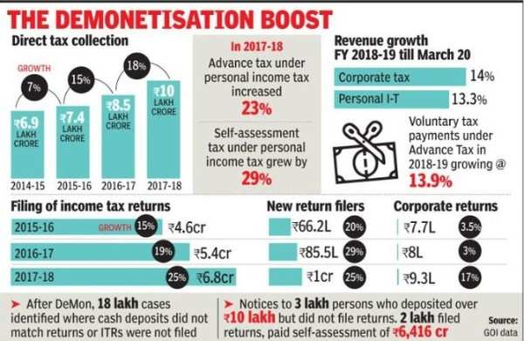

iii) Decrease in Currency in Circulation
Before demonetization, currency in circulation was Rs 18.4 lakh crore, approximately 12 per cent of the GDP, and was too high and not sustainable. Nevertheless, even post-demonetization, the currency in circulation has decreased significantly to Rs 15.32 lakh crore, down by more than Rs 3 lakh crore prior to pre-demonetization and translates to around 9 per cent of GDP and seems to be a more manageable level.
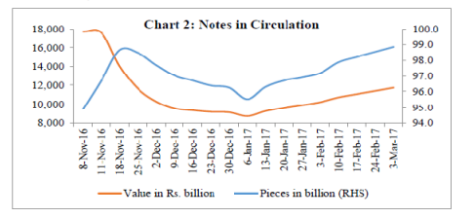

iv) Effect on GDP growth
On the flip side, demonetization brought an enormous negative effect on employment and GDP growth in 2016-2018. The economy that was recovering mode after elections and was growing at around 8 per cent in Q4 of 2015-16, gradually fell to 5.7 per cent in Q2 of 2017-18, which had a significant effect on fiscal deficit and government expenditure for social schemes.
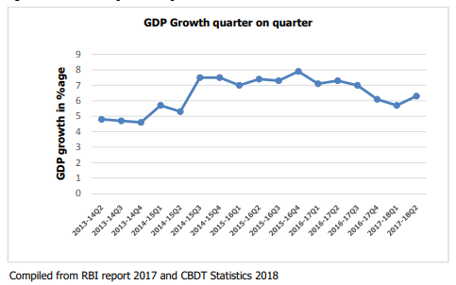
CONCLUSION
This process will enable India to build a tax compliant and transparent society. But it was achieved at enormous social and economic price and inflicted a lot of hardship to the ordinary people's lives. Several individuals lost their lives while waiting in line for the exchange of money in front of banks. It is held by everybody that even though demonetization was a right move, it could have been done with greater planning and preparation.
Thus, it can be said that demonetization 2016 had both positive and negative effects on the economy. But there is wide consensus that even though a small amount of GDP growth was lost and a transient welfare loss to the unorganized sector was incurred because of the demonetization exercise, but the initiative served to decontaminate the system to a great degree and will be a long way in transforming India into a transparent and tax compliant nation.

Made By- Sayyam Mehta
Course- BA Economics Honors
Year and Semester- 2ND Year, 4th Semester

